

CENTENNIAL COLLEGE PROGRESS CAMPUS

COURSE COMP125 Winter 2020

ASSIGNMENT #4

Form Validation

Create an HTML document called assignment4.html that collects the following information from the user:
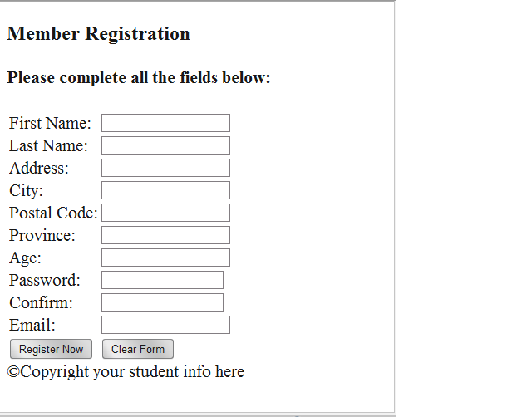

Next modify assignment4.html to include the JavaScript code required for field validation.

Following are the guidelines for validating the user input:

→ All the fields are mandatory (cannot be left blank: varExample !== “” )

→ The postal code has to be in the a0a0a0 format – (research it on the internet Regular Expression for Canadian Postal Code)

→ Province is one of QC, ON, MN, SK, AB, BC. Don’t use Select element. Use an Array and compare each value in a loop.

→ Age has to be at least 18 yrs. old.

→ The Email field must contain the @ and . characters
(5% of the mark for using a regular expression – research it on the internet)

→ The Confirm Password and Password fields should have identical input.

→ Passwords must have at least 6 characters and must contain at least one digit and one upper-case character.
(5% of the mark for using a regular expression – research it on the internet)

When the form fields pass validation, an alert message is displayed to show a confirmation message (e.g. “Thanks for registering with our website, your customer record was created successfully.”).

(10% of the mark) Customize/design your page using a CSS style sheet and graphics of your choice. Include a banner area with graphics and a title of your choice, add additional visual enhancements to the page as you consider suitable.

Submission:
- This assignment is due to March 19th at 11:30 pm.
- Late assignments are accepted seven (7) more days after the due date and they are marked out of 80%.
- Upload the html document, the JavaScript file, and all supporting files to the studentweb server.
- Submit your assignment to Assignment 4 drop box.
  - Paste in the text field the path (link) to your assignment 4 page (pointing to the assignment4.html file).

